Motion Planning Assignment 2

Submitted by: Purna Patel

WPI ID: 150062312

**Probabilistic Road Map:**

**Uniform Sampling:**

* Samples are distributed evenly throughout the C-space.
* Advantages:
  + Faster than gaussian sampling and bridge sampling.
  + Points are distributed evenly throughout the space and so it covers every part of the C-space.
  + No need to tune the parameters.
* Disadvantages:
  + Fail to capture narrow gaps and paths.

**Random Sampling:**

* Samples are distributed randomly across the C-space.
* Advantages:
  + Faster than all other sampling methods.
  + No need to tune the parameters.
* Disadvantages:
  + Points may not be distributed evenly across the C-space so it may not cover every part of the C-space.
  + Fail to capture narrow gaps.

**Gaussian Sampling:**

* Uses gaussian distribution to sample the space and the sampling condition guides the distribution towards the edge of the obstacles.
* Advantages:
  + Captures the edges of the obstacles.
  + Better in capturing narrow gaps than uniform and random sampling.
  + Samples are distributed around the obstacles.
* Disadvantages:
  + Slower than Uniform and Random sampling.
  + Samples are distributed in clusters among the C-space and so it fails to capture other region where there are less obstacles.
  + Parameters like scale of gaussian distribution, max distance for the nearest neighbours etc. needed to be tuned for consistent performance.

**Bridge Sampling:**

* This algorithm guides the sample distribution towards the gaps between the obstacles.
* Advantages:
  + Consistently captures the narrow gaps.
* Disadvantages:
  + Slowest of all other sampling methods.
  + Samples are distributed in clusters among gaps and corners and so it does not capture other parts of the C-space.
  + If not tuned well, frequently fails to find a path.
  + Parameters like scale of gaussian distribution, max distance for the nearest neighbours etc. needed to be tuned for good performance.

**Rapidly exploring Random Tree:**

**RRT:**

* RRT is a single query roadmap which computes only one roadmap for each new query.
* This optimizes the computation time compared to the multi-query methods.
* Advantages:
  + Computationally very light compared to RRT*.
  + Finds a path very quickly.
  + Due to goal bias, the search is guided towards the goal and so the nodes explored in other direction are less.
  + Less tuning parameters.
* Disadvantages:
  + The path found is not optimal.

**RRT*:**

* RRT* is also a single roadmap like RRT but the difference is it do not stop the search after goal is found.
* Instead, it keeps on rewiring the nodes as new nodes are found and thus it keeps on optimizing the path.
* Advantages:
  + Path found is optimal.
  + Due to rewiring, the path found is smooth compared to other roadmaps.
  + Do not terminate after the goal is found and so it keeps on looking for better path.
* Disadvantages:
  + Computationally very heavy.
  + Needs tuning of parameters for good and consistent performance.
  + Very slow compared to normal RRT.

**Comparison between PRM and RRT:**

|  |  |
| --- | --- |
| **PRM** | **RRT** |
| Multi-query roadmap method | Single-query roadmap method |
| Different steps for exploring and searching | Explores and search simultaneously |
| Do not work for dynamic environment | Can work for dynamic environment |

**Algorithm Results and explanation:**

**PRM:**

**Uniform Sampling:**

* Following was the result found using Uniform sampling based PRM.

* As seen in the graph, the samples are distributed evenly among the C-space.
* There are very less samples distributed in the narrow gaps and so it is possible that it might miss the optimum path.

**Random Sampling:**

* Following was the result found using Random sampling based PRM.

* As seen in the graph, the samples are distributed randomly among the C-space.
* There are very less samples distributed in the narrow gaps and so it is possible that it might miss the optimum path.

**Gaussian Sampling:**

* Following was the result found using Gaussian sampling based PRM.

* As seen in the graph, the samples are distributed along the edges of the obstacles.
* As the density of samples along empty region is less, in order to find path, the number of neighbours assigned to the start and goal position is set to 50.
* This sampling performs better in capturing the narrow gaps.

**Bridge Sampling:**

* Following was the result found using Gaussian sampling based PRM.

* As seen from the graph, the samples are clustered along the gaps.
* This sampling method performs best in capturing the narrow gaps.
* But other region is not sampled and hence it often fails to generate a path.
* To overcome this drawback, number of neighbours to start and goal are increased.

**RRT variants:**

**RRT:**

* Following was the result found using simple RRT algorithm.

* It is seen in the graph that very less samples are explored.
* This makes RRT least computationally heavy.
* But the path obtained is not optimal.

**RRT*:**

* Following was the result found using RRT* algorithm.

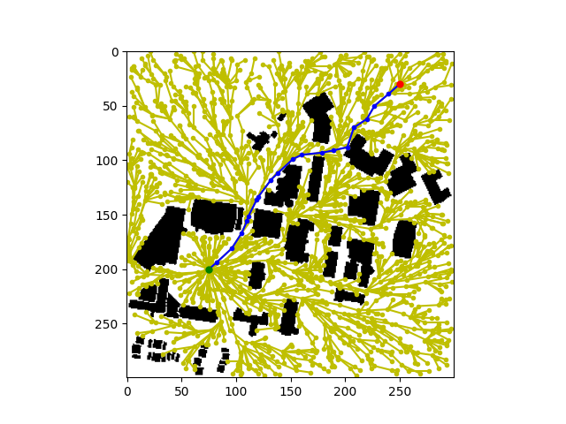

* RRT* was successfully able to find the optimal solution.
* Rewiring step helps find the optimal solution.
* But this makes the algorithm very computationally heavy.